
LABORATORY PROJECT REPORT
SERIAL CONNECTION BETWEEN ARDUINO AND PYTHON
EXPERIMENT 3A

SECTION 1
GROUP 7

NO | NAME | MATRIC NO
1 | MUHAMMAD FARISH BIN AB LATIF | 2329227
2 | MUHAMMAD FARQI SARHIDI BIN ABDUL HAFAZ | 2316461
3 | MUHAMMAD DANISH BIN MOHD HANIFAH | 2311377
DATE OF SUBMISSION: 25 MARCH 2026

Abstract

This study examines the implementation of real-time serial communication between an Arduino Uno microcontroller and a Python-based computing environment. The primary objective was to establish a seamless data pipeline, beginning with a potentiometer to generate variable analog signals which were then processed by the microcontroller and transmitted via a USB serial link. By utilizing the pyserial library, the Python script was able to move beyond static data logging to achieve a dynamic, graphical representation of the sensor’s behavior.
The core of the experiment focused on the technical nuances of system integration, particularly the precision required for analog-to-digital conversion and the necessity of exact baud rate synchronization to maintain signal integrity. By managing these hardware inputs within a high-level software environment, the setup demonstrated how raw electrical signals can be effectively transformed into actionable visual data. Ultimately, the results confirm that robust serial exchange remains a fundamental requirement for the synchronization of modern mechatronic and embedded systems.

Table of Contents
1.0 Introduction
2.0 Materials and Equipment
2.1 Electronic Components
2.2 Equipment and Tools
3.0 Experimental Setup
4.0 Methodology
5.0 Data Collection
6.0 Data Analysis
7.0 Results
8.0 Discussion
9.0 Conclusion
10.0 Recommendations
11.0 References

- Introduction

Modern mechatronics relies heavily on the seamless exchange of information between microcontrollers and high-level computing environments. This interaction is foundational for data acquisition, system monitoring, and precise control. This experiment explores these principles by establishing a functional link between an Arduino board and a Python-based interface, specifically to monitor and visualize inputs from a potentiometer. In this experiment, the Arduino serves as the primary acquisition unit, transforming the analog voltage from the sensor into digital values. These signals are then streamed via a USB serial connection to a computer, where a Python script that uses the pyserial library intercepts and displays the readings dynamically. This setup provides a hands-on look at critical technical hurdles, such as ensuring signal integrity through analog-to-digital conversion and maintaining strict synchronization by baud rate alignment. Beyond the immediate hardware configuration, the experiment bridges the gap between low-level firmware and high-level software. It reinforces the programming logic required to handle real-time data streams while demonstrating the core principles of sensor interfacing and visualization. Ultimately, mastering these communication parameters is essential for developing the automated, responsive systems that define current mechatronic applications

2.0 Material and Equipment.

2.1 Electronic Components
● Arduino Uno – Microcontroller board for controlling the display
● Potentiometer – A variable resistor used to generate varying analog voltage levels.
● 220-Ohm Resistors – Current-limiting resistors for each segment of the display
● LED – Optional visual indicator for circuit verification or output indication.
● Jumper Wires – For making connections between components
● Breadboard – For assembling the circuit without soldering

2.2 Equipment and Tools
● Arduino IDE – Software for writing and uploading code to the Arduino Uno
● USB Cable – For connecting the Arduino Uno to a computer
● Power Supply (5V via USB or external source) – To power the circuit
● Python with PySerial Library – Used to establish and manage serial communication with
the Arduino and display real-time data.

3.0 Experimental Setup
3.1 Task 1

1. The potentiometer was connected to the Arduino Uno with one leg to 5V pin on Arduino,
the other leg to gnd, and middle leg to pin A0.
2. Arduino was connected to the computer via USB, as shown in Figure 1, and run the
Python script to begin reading potentiometer values in the terminal.
3. The potentiometer knob was adjusted to observe the values displayed in real-time
4. Serial plotter in Arduino IDE was opened to view the real time data fron the
potentiometer adjustment.
5. An LED connected to the pin 9 and 220-ohm resistor added as an optional output
indicator connected to a digital pin to observe visual feedback after the potentiometer
value exceeded half.
6. All components were connected using jumper wires on a breadboard for a secure and
solderless setup.

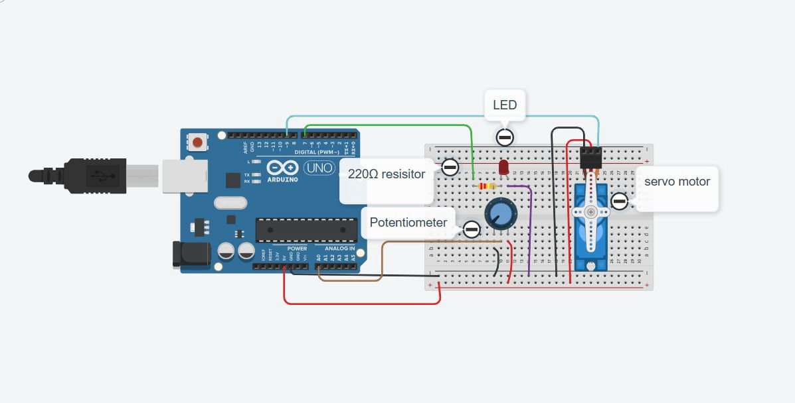
Figure 1:shows the circit assembly

3.2 Task 2

1. Connect the potentiometer to the Arduino Uno:
- Connect the left potentiometer pin to the GND.
- Connect the middle pin to the analog pin (A0).
- Connect the right pin to the 5V pin.
2. Connect the led to the Arduino:
- Connect the cathode or negative leg of the LED to the GND pin.
- Connect the 220Ω resistor to the anode or positive leg of the LED.
- Connect the other end of the resistor to one of the digital pins (D7).
3. Connect the servo to the Arduino:
- Connect the brown wire to the GND pin.
- Connect the red wire to the 5V pin.
- ●Connect the orange wire to one of the digital pins (D9).

4.0 Methodology

1. Setup the Arduino Uno
2. IDE code implementation
3. Testing the terminal in python
4. Use the serial plotter in IDE
5. Code snippet

4.1 Detail steps
1. Assemble the circuit as stated in the experimental setup.
2. Connect the Arduino to the computer via usb cable and upload the code to Arduino IDE.
3. Open the serial plotter on the Arduino to see the real time values of the potentiometer.

4.2 Programming codes
Arduino code

const int potPin = A0; // Potentiometer connected to analog pin A0
const int ledPin = 9; // LED connected to digital pin 9 (through 220Ω resistor)
void setup() {
Serial.begin(9600);
pinMode(ledPin, OUTPUT); // Set LED pin as output
}
void loop() {
int potValue = analogRead(potPin); // Read potentiometer value (0–1023)
Serial.println(potValue);
// Check if potentiometer value exceeds half of maximum (1023/2 = 511)
if (potValue > 511) {
digitalWrite(ledPin, HIGH); // Turn LED ON
} else {
digitalWrite(ledPin, LOW); // Turn LED OFF
}
delay(1000); // Wait for 1 second
}
Python code
import serial
ser = serial.Serial('COM5', 9600)
try:
while True:
pot_value = ser.readline().decode().strip()
print("Potentiometer Value:", pot_value)
except KeyboardInterrupt:
ser.close()
print("Serial connection closed.")

5.0 DATA COLLECTION

5.1 Task 1

Potentiometer Position | ADC Value (0-1023) | LED Status (ON/OFF)
0% turn | 0 | OFF
50%turn | 512 | OFF
100% turn | 1023 | ON

5.2 Task 2

Potentiometer Input  (ADC) | Mapped Servo Angle  (∘) | LED Status (ON/OFF)
0 | 0 | OFF
512 | 90 | OFF
1023 | 180 | ON

6.0 Data Analysis
6.1 Task 1

Based on the results obtained in Task 1, the relationship between the potentiometer position and the ADC value shows a linear behaviours table shows how the potentiometer position changes the ADC value. When the potentiometer is at the starting position of 0% turn, the ADC value is exactly 0. As the knob is turned to the middle position of 50% turn, the ADC value increases to 512. When the potentiometer is turned all the way to 100% turn, the ADC value reaches its maximum point at 1023.
This shows that the ADC value goes up in a straight line as the user turns the potentiometer. The data also shows how the LED light reacts to these different values. At the 0% turn position, the LED status is OFF because the value is too low. Even when the potentiometer is moved to the 50% turn position and the value reaches 512, the LED status still remains OFF. The LED only changes its status to ON when the potentiometer reaches the full 100% turn and the ADC value is at the maximum of 1023.
In conclusion, the system uses the potentiometer to create a digital number between 0 and 1023. The light does not turn on for small or medium numbers like 0 or 512. The computer or controller is programmed to wait until the number is very high at 1023 before it sends power to the LED. This means the LED only works when the sensor is at its highest possible limit.

6.2 Task 2
Based on the results obtained in Task 2, a clear and consistent relationship can be observed between the potentiometer input (ADC value) and the mapped servo angle. When the input starts at a value of 0, the servo motor does not move and stays at 0°. As the input increases to the middle value of 512, the system maps this number to a servo angle of 90°. Finally, when the potentiometer input reaches its maximum of 1023, the servo motor turns all the way to its maximum position of 180°. This proves that there is a direct relationship where higher ADC numbers make the servo motor rotate to a wider angle. The data also describes when the LED light turns on or off based on these values. At the beginning, with an ADC value of 0 and a servo angle of 0°, the LED status is recorded as OFF. When the input increases to 512 and the servo moves to 90°, the LED status still remains OFF. The LED only changes its state and becomes ON when the system reaches the very end of its range. This happens only when the ADC value is 1023 and the servo motor is at the 180° position.
In conclusion, the system is designed to control two different things at the same time using one input. The servo motor moves continuously from 0 to 180 degrees as the input grows, but the LED is different because it stays off for most of the time. The LED is programmed with a high threshold, meaning it will only light up when the servo has finished its full rotation. This setup ensures that the user gets a visual light signal only when the system has reached its maximum physical limit.
7.0 Results
7.1 Task 1

The result from this experiment is the LED is turned on when the value of potentiometer
reaches half of its maximum. This shows that the serial data transmission from arduino to
python is successful. The arduino successfully read the value of potentiometer and
transmitted to the python via USB serial communication. Diagram 7.1.1 is the connection of
the circuit.The potentiometer is connected in Analog pin in the arduino while led is connected
in digital in the Arduino. After that, the terminal of the Phyton shows the real time value of
the potentiometer. The value displayed changed as the potentiometer knob turned.
Furthermore, the red LED is turned on when the value of potentiometer exceeds half of its
value. It shows that the LED successfully integrated in the circuit.

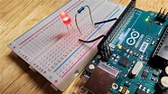
Figure 2: shows LED turn on

7.2 Task 2
In this experiment, the servo angle successfully turned in a specific angle according to the movement of the potentiometer knob. This shows that the system is using real time adjustment and the servo motor can be controlled using potentiometer. After that, we used matplot lib in this experiment to see the real time potentiometer value. The dynamic graph was successfully generated using the python. This experiment also integrated with the experiment in task 1. From this we can know that the value of the potentiometer is exceed half and the angle of the servo motor is over 90 degrees.

8.0 Discussion
8.1 Task 1
The experiment demonstrates that When the potentiometer is at the 0% turn position, the ADC value is 0 and the LED remains OFF. As the knob is turned to the middle position of 50% turn, the ADC value increases to 512, but the LED status still stays OFF. The LED only switches to the ON status when the potentiometer reaches the full 100% turn and the ADC value is at the maximum of 1023. This experiment proves that the ADC value goes up in a straight line as the user turns the knob. The system is programmed with a high threshold so that the light only triggers when the sensor reaches its highest possible limit. Using a potentiometer to control an LED like this is very useful for machines that need to show when a part has reached its final position.
8.2 Task 2
The experiment demonstrates that the potentiometer input directly controls the movement of the servo motor and the status of the LED at the same time. When the potentiometer input is at its lowest value of 0, the servo motor stays at 0 degrees and the LED remains in the OFF position. As the input value increases to the middle point of 512, the system maps this data to move the servo motor to a 90-degree angle, but the LED status still stays OFF during this middle stage. The system is designed so that the LED only switches to the ON status when the potentiometer input reaches its maximum value of 1023 and the servo motor has completed its full rotation to 180 degrees. This relationship shows that while the servo motor moves in a linear way according to the input, the LED acts as a signal that only triggers when the system reaches its highest limit. In a practical application like a dough sheet maker, this setup allows a user to adjust a machine's position smoothly while receiving a light notification only when the rollers reach their maximum opening. Overall, the data confirms that one sensor can effectively manage multiple outputs with different behaviors to ensure the machine operates correctly

9.0 Conclusion
In conclusion, the objective of the experiment is to use USB serial communication to transfer potentiometer readings from the Arduino to Python, which was successfully achieved. Real-time data transmission confirmed that the analog readings from the Arduino could be accurately recorded and analyzed in Python. The inclusion of the LED clearly demonstrated how external components can be controlled based on the transmitted data. Overall, this setup highlights the flexibility of Arduino–Python integration for applications such as automation, monitoring, and data collection.

10.0 Recommendations
To get the best results, it is recommended to always double-check the wiring of the potentiometer to ensure the connections to the 5V and GND pins are secure, as loose wires can cause the ADC value to jump around. Before you start recording data, you should make sure the COM port and the baud rate in your code match the settings on your computer so that the serial monitor can read the values properly. Because the LED only turns on at the maximum value of 1023, it is a good idea to add a small "buffer" or range in the code, such as turning the LED on when the value is above 1000, to make it easier for the user to trigger the light.
To make the system more advanced, you can implement data smoothing or a simple moving average in your programming to remove any electrical noise and make the ADC readings more stable. Since you are interested in industrial automation and PLCs, you could also try expanding the experiment by adding a second LED that turns on at 50% turn (512) to show different stages of a process. Finally, always remember to close the Serial Plotter or Serial Monitor before you try to upload new code to the board to avoid communication errors with the hardware.

11.0 References
- Week 3: Serial Communication (Version 3)
https://drive.google.com/drive/folders/1QecGGN96D76UL2gwBjevFwiEXv2UEniO
- Python for undergraduate engineers: Using python and arduino to read sensor
https://pythonforundergradengineers.com/python-arduino-potentiometer.html

12. Acknowledgments
Special thanks to ZULKIFLI BIN ZAINAL ABIDIN for his sharing the tips and support
during this experiment, even though it is a take-home experiment.

Student’s Declaration
Certificate of Originality and Authenticity
We hereby certify that we are collectively responsible for the work presented in this report. The content reflects our original work, except where specific references or acknowledgements have been made. No part of this report has been completed or submitted by individuals or sources not identified within.
Furthermore, we confirm that this report is the result of a collaborative effort, with contributions made by all group members. The extent of each individual’s contribution is documented within this certificate.
We also hereby certify that we have read and understand the content of the total report and no further improvement on the reports is needed from any of the individual’s contributors to the report.
We, therefore, agreed unanimously that this report shall be submitted for marking and this final printed report has been verified by us.

Name: Muhammad Farish Bin AB latif Read [/]
Matric Number: 2329227 Understand [/]
Signature: Agree [/]

Name: Muhammad Farqi Sarhidi Bin Abdul Hafaz Read [/]
Matric Number:2316461 Understand [/]
Signature: Agree [/]

Name: Muhammad Danish Bin Mohd Hanifah Read [/]
Matric Number:2311377 Understand [/]
Signature: Agree [/]

